Project Title: AI based localization and classification of skin disease with erythema Project Design Phase-I - Solution Fit Template Team ID: PNT2022TMID34120



_

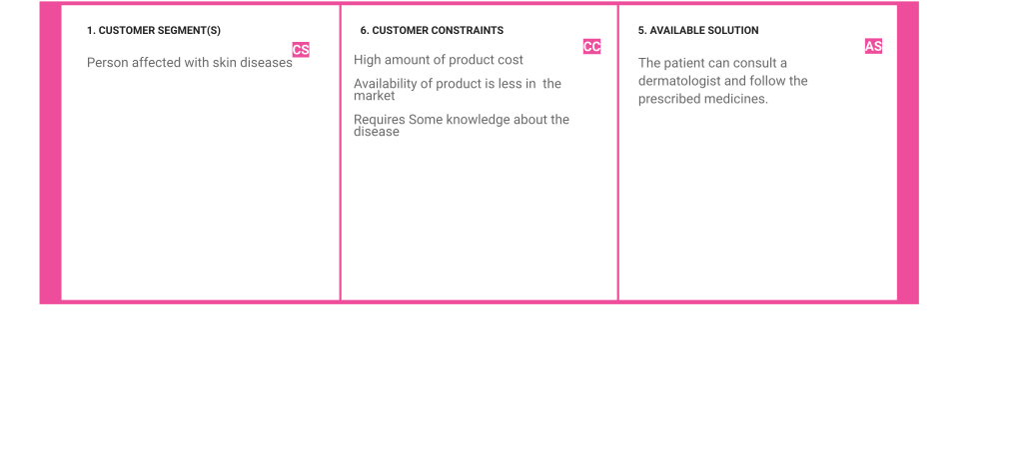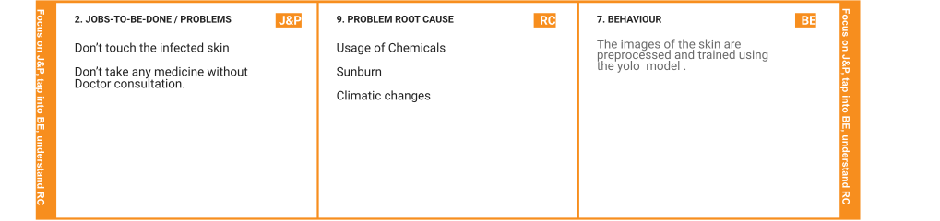



|  |  |  |  |  |  |
| --- | --- | --- | --- | --- | --- |
| **Identify strong TR & EM** | **3. TRIGGERS**  **T R**  The customers heard the news | **10. YOUR SOLUTION**  The allergic skin images are uploaded in the application ,it will detect whether the patient | **S L** | 1. **CHANNELS of BEHAVIOUR**   **C H**   * 1. **ONLINE**   Online Consultation  Search reference video and do self treatment   * 1. **OFFLINE**   Consult a Dermatologist  Take Traditional Treatments |  |
|  | about the eﬃciency of our model | has erythema or not. |  |
|  | and installed our application. |  |  |
|  | **4. EMOTIONS: BEFORE / AFTER** |  |  |
|  | **BEFORE :** |  |  |
|  | The Patient is frustrated and worried about his skin disease. |  |  |
|  | **AFTER :** |  |  |
|  | Now the Patient got relief from his disease and became happy. |  |  |
|  | **E M** |  |  |